Event Name
Year
Event Health and Safety Plan

Contents
Event Health and Safety Policy 2
Event details 3
Site Plan 4
Contributory factors 5
Key responsibilities and contact details 7
Contractors for the Event 8
Risk Assessment Matrix 9
Appendix 13
Incident Report 14
Lost Child/Vulnerable Persons Report 15
Major Medical / Major First Aid Emergency 16
Fire 17

Event Health and Safety Policy

Company/Organisation recognises its responsibility to protect the health, safety, and welfare of all people directly associated with the event, including members of the public, whether attending the event or not.
We are committed to provide a safe environment for everyone to the best of our ability. The details are set out in the event specific Health and Safety Plan which complies with the requirements set out in Health and Safety at Work Act 2015 (HSWA) and other relevant legislation.
We confirm that the following requirements are part of the plan:
- A process is in place for the hazard identification, risk assessment, and control of hazards
- Monitoring and review of control measures for hazards at intervals appropriate to the event to ensure effectiveness.
- Health and Safety responsibilities are clearly assigned to designated persons
- An accident record is kept on site and in accordance with WorkSafe New Zealand [see https://worksafe.govt.nz/ for further information and downloadable templates]
- All participants at the event possess the necessary knowledge, skills, and training that enable them to perform their job adequately
- The event location has been inspected by the designated health and safety person to ensure the venue’s safety
- Develop and provide an overall emergency plan which takes into consideration the event location, pack-in, pack-out, event activities, and any specialist procedures and instruction that may be required.

Event Organiser
Name:
Role:
Date:
Signature:

Event details
Event name:
Event location:
(e.g. name of park/beach/public building including address)
Event date/s and time/s: | Event start date: Click here to enter a date. |  | Event end date: Click here to enter a date.
 | Event start time: |  | Event end time:
 | Pack-in date: Click here to enter a date. |  | Pack-out date: Click here to enter a date.
 | Pack-in time: |  | Pack-out time:
Event organiser contact details: | Contact name:
 | Mobile:  Phone:  Email: |  | Address:
New Plymouth District Council  Officer/Event Facilitator: | Name:
 | Email:
 | Phone/Mobile:
Event description: (briefly outline the nature of the event)

Site Plan
Insert here or attach in appendix

Contributory factors

Participants and spectators: | Yes | No | Expected number of persons:
Participants | ☐ | ☐
Employees | ☐ | ☐
Contractors | ☐ | ☐
Volunteers | ☐ | ☐
Vendors | ☐ | ☐
Others | ☐ | ☐
Spectators | ☐ | ☐
Other contributory factors  Refer to Event H&S Management Guidelines (Risk Control section) and add actions to your ‘Risk Control plan’). | Yes | No | Risk Control Section Reference(s):
Do event activities deliberately expose participants to a serious risk (e.g. Abseiling, bridge swinging) covered by the Adventure Activities Regulations?  (If YES, please attach a copy of your current registration as a Certified Adventure Activity operator). | ☐ | ☐ | ‘Adventure activities’
Presence of alcohol | ☐ | ☐ | ‘Alcohol’, ‘Crowd management’, ‘Security procedure’
Amusement devices (e.g. fairground machinery) | ☐ | ☐ | ‘Amusement devices’
Involvement of animals | ☐ | ☐ | ‘Animals’
Involvement of children and vulnerable persons | ☐ | ☐ | ‘Children/vulnerable persons’
Electrical equipment/installations | ☐ | ☐ | ‘Electricity’
Food stalls | ☐ | ☐ | ‘Food Safety’
Ground Penetrations (e.g. marquee pegs, hangi) | ☐ | ☐ | ‘Ground penetrations’
Inflatables (e.g. bouncy castles) | ☐ | ☐ | ‘Inflatables’
Use of Liquefied petroleum gas (LPG) | ☐ | ☐ | ‘Liquefied petroleum gas (LPG)’
Maritime Events or events in or around water | ☐ | ☐ | ‘Water’
Use of amplified noise (e.g. sound system) | ☐ | ☐ | ‘Noise’
Onsite refuelling of vehicles or equipment (e.g. race cars, generators) | ☐ | ☐ | ‘Refuelling of vehicles or equipment’
Exposure to weather conditions would impact safety (e.g. outdoor events) | ☐ | ☐ | ‘Severe weather’
Use of special effects (e.g. pyrotechnics/fireworks, fire performance) | ☐ | ☐ | ‘Special effects/Pyrotechnics’
Use of temporary structures (Tents, marquees etc) | ☐ | ☐ | ‘Temporary structures’
Event takes place on the road/footpath or is likely to significantly increase the normal traffic flow in the area. | ☐ | ☐ | ‘Traffic Management Plan (TMP)’
Use of Unmanned aircraft (e.g. Drones) | ☐ | ☐ | ‘Unmanned aircraft’
Vehicle movement onsite (e.g. event set up, parades) | ☐ | ☐ | ‘Vehicle movement’
Working/performing at heights (e.g. scaffolding, lighting installation, stages, elevated work platforms) | ☐ | ☐ | ‘Working at heights’

Key responsibilities and contact details
Note: Please proved details of key contact person/s during the event and after hours
Responsibility | Name of contact person | Contact number (preferably mobile) | Company name
Event management

Designated H&S person

First aid

Emergency control

Security

Traffic management (incl. parking)
Waste management

Lost children

Welfare of animals

Liaison with emergency services
Maritime/Water Safety

Contractors for the Event
Note: Please proved details of key contact person/s during the event.
Type of Service | Deliverables | Company name | Contact person and number (preferably mobile)
Amusement equipment

Electrical

Food stalls

Pyrotechnics

Scaffolding

Security

Traffic Management

LP Gas

Cleaning and Waste

Drinking Water

Ablution facilities

Continued…

Risk Assessment Matrix

Risk is determined by multiplying the Likelihood of injury/damage by the Consequence
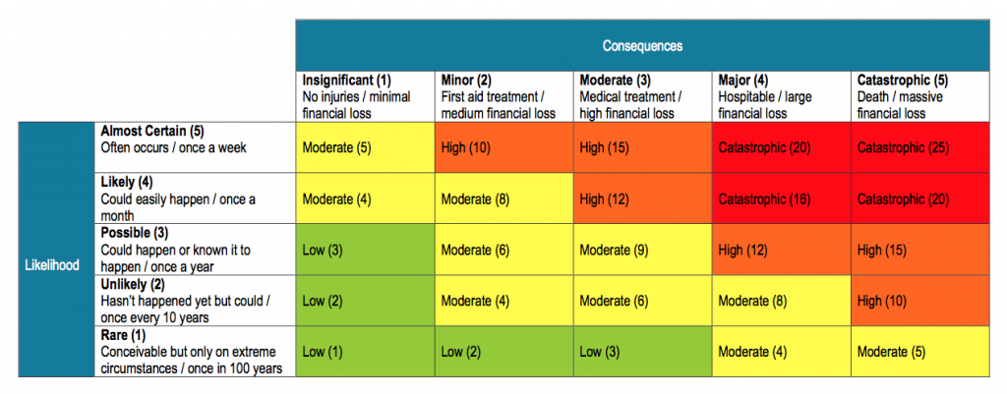
Resources:
Identifying, assessing and managing work risks (Worksafe NZ)
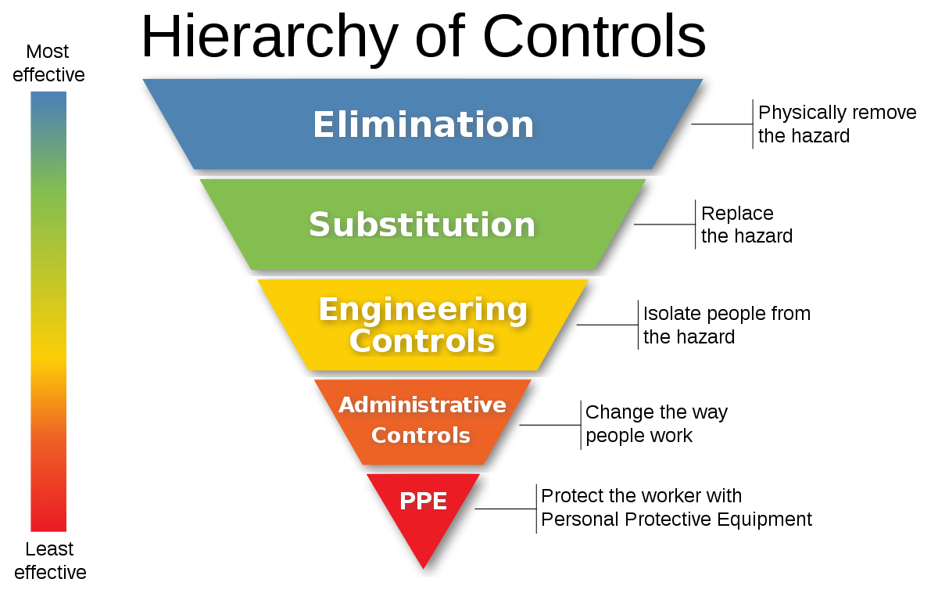
Event Risk Control Plan - Hazard Identification and Risk Assessment
Hazard or Risk identified. | Overall Risk Level | Level of Control  (see previous page) |  |  |  |  | Action
What could go wrong? | Low  Mod  High  Critical | Eliminate | Substitute | Engineer control | Admin Control | PPE | How will we prevent it? | Person responsible | What we will do if it happens?
Example: Sunstroke or heat exhaustion | Mod | no | no | yes | yes | yes | Proper clothing / hat  Sunscreen / sun block  Event schedules  Shade provided at multiple sites | Event Manager | Refer to onsite first aid

Appendix

Incident Report Form
Lost Child Report
Emergency Response Plans

Incident Report
Particulars of incident:
Date: | Time: |  | Location:
Type of incident (please circle below):
Injury Illness Environmental Notifiable event Other:
Reported by: |  |  | Phone:
Role in the event: |  |  | Email:
The injured person:
Name: |  |  | Address:
Age: |  | Phone:
Witness(s):
Name: |  |  | Phone:
Name: |  |  | Phone:
Name: |  |  | Phone:
Describe the incident: (space overleaf for diagram if needed)
Describe any illness or injury: What part of the body is affected and how?
Describe any property damage: What damage was caused and how?
Analysis: What do you think caused or contributed to the incident?
How serious could it have been? (please circle) Minor Serious Very Serious
How often is this likely to happen again? (please circle) Never Rarely Occasionally Often
Prevention: What action has been taken to prevent a reoccurrence?
Have all preventative actions been reviewed by the Event Management Committee, and implemented? Yes No
Signature: |  |  | Date completed:
Treatment:
A & E Hospital: |  |  | Doctor:
Type of treatment provided:
Notification and investigation WORKSAFE PHONE: 0800 030 040 (24 hours)
Worksafe NZ advised by: |  |  | Date:
Investigation conducted by: |  |  | Date:
Risk Register updated by: |  |  | Date:

Lost Child/Vulnerable Persons Report

Event: | Name: | Date: | Time:
Report written by: | Name:  Job title:
Person who delivers child | Name:  Mobile/phone: | Address:
Location where child was found: | Location:
Child Details: | Name:
 | Gender: | Ethnicity:
 | Age: | Eye colour:
 | Mobile number (if applicable): | Clothing:
 |  | Hair Colour:
Caregiver/parent details: | Name:  Relationship to child:
 | Mobile: | Address:
 | Phone:
 | Email:

________________________________ ________________________________
Signature(s) of caregiver Signature(s) of responsible event staff

Major Medical / Major First Aid Emergency
Initial action
Ascertain details: | - Location; problem; number of patients; mechanism of injury (trauma); prior medical history (medical).
Notify: | - Notify event safety service / medical team, call 111 and ask for ambulance, inform next of kin of the involved.
Consider: | - Is there a risk/hazard posed for other people? Does the event need to stop temporarily to allocate safety resources to the incident(s)? Is there an appropriate environment to treat the victim(s)?
Complete Incident Log: | - Record time; date; informant details; arrival of additional support; any treatment provided; patient information.
At scene
Actions: | - DRSABC (Danger Response Airways Breathing Circulation) is the priority protocol followed by secondary surveys (trauma + medical) to ascertain the problem and provide appropriate care.  - Consider the ongoing treatment of the patient, and whether they need to be moved to a more appropriate environment (i.e. out of direct sun, wind, water etc).
At completion
Debrief: | - In serious/critical incident trauma and medical cases, the Event Safety Officer should lead a debrief session of the incident to assess, and ensure all persons involved are OK (emotionally and physically). The response process should be reflected, after all learnings have been recorded.  - The debrief process is not a forum for apportioning blame for any errors, rather an opportunity to discuss what happened (facts) from each person’s perspective, and to identify any person(s) that require additional support.  - In a critical incident such as a death or severe (life threatening) trauma, it is likely Work Safe NZ will need to be notified.
Reporting: | - Ensure an Event Incident Report Form is completed for any incident.  - Ensure Incident Forms are submitted to the Event Manager for any follow up required, and filing in the Event Risk Management Records.  - Feel free to attach additional information as required. It is beneficial to keep a more detailed account of the incident in the event of a formal investigation.

Fire
Initial Action
Ascertain details: | - Location; problem; number of patients; likely source of fuel; level of threat to people and/or property.
Notify: | - Notify event safety service / medical team. Call 111, and ask for fire service. If aware of injured people, request an ambulance response.
Consider: | - Is there a risk/hazard posed for people or property?  - Does the event need to stop temporarily to allocate resources to the incident to put out or control a fire; protect people; and move to safer area etc?
Complete Incident Log: | - Record time; date; informant details; arrival of additional support; any treatment provided re patient information.
At scene
Actions: | - All involved are reminded that self-preservation is a priority in any response.  - People are a priority over property in the case of a fire. Ensure the protection of people initially before considering protection of property.  - Assess the availability of resources to mitigate the fire (i.e. water, hoses, buckets, capable people etc).  - For any people affected, DR ABC is the priority protocol followed by secondary surveys (trauma + medical) to ascertain the problem, and provide appropriate care.  - Once on site, the NZ Fire Service will take over management of the incident, and provide direction to event organisers.
At completion
Debrief: | - In a serious or critical incident trauma and medical cases, the Event Safety Officer should lead debriefs of the incident/s to assess, and ensure all persons involved are safe and well (emotionally and physically). The response process should be reflected from the learnings recorded.  - The debrief process is not a forum for apportioning blame for any errors, rather an opportunity to discuss what happened (facts) from each person’s perspective, and to identify any person(s) that require additional support.  - In a critical incident, such as a death or severe (life threatening) trauma, it is likely Work Safe NZ will need to be notified.
Reporting: | - Ensure an Event Incident Report Form is completed for any incident.  - Ensure incident forms are submitted to the Event Manager for any follow up required, and filing in the Event Risk Management Records.  - Feel free to attach additional information as required. It is beneficial to keep a more detailed account of the incident in the event of a formal investigation.

